SRMS (MRI) Issues

1. Batch issues
   1. Unposted closed batch
   2. Batch period not identical
   3. Batch locked
      1. If batch is locked and unable to post, use the SQL below and change batch status to ‘L’
      2. Unlock the batch on SRMS and post afterwards

update cmbtch set status = 'L' where cmbatchid = 'E7420124'

d. Unlock and Post batch in SRMS

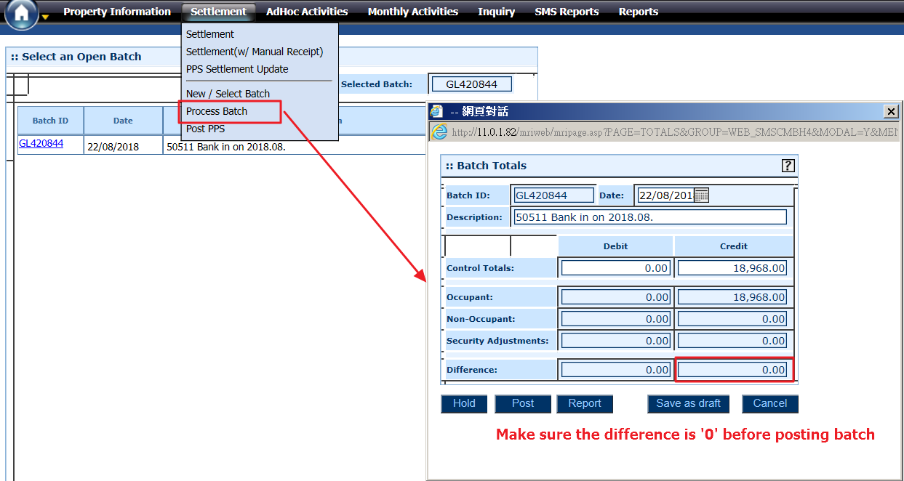

1. Communication Centre issues
   1. Clear communication centre to retrieve back receipts/demand notes
      1. Execute the below SQL script by inputting user staff ID and current post time

update [MRISystem].[dbo].[MRI_Server_Messages] set status = 0

where userid like '%602880%' and posted_time <= '20180807 08:00'

1. SRMS on Windows 10
   1. Internet Options > Security > Set to lowest Security Level

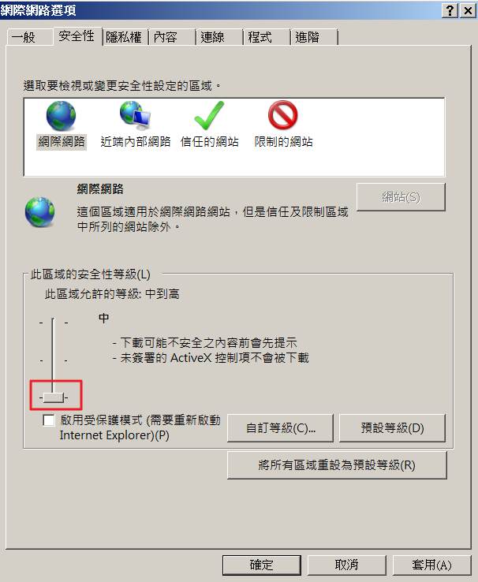

* 1. Compatibility View Settings > Add MRI IP

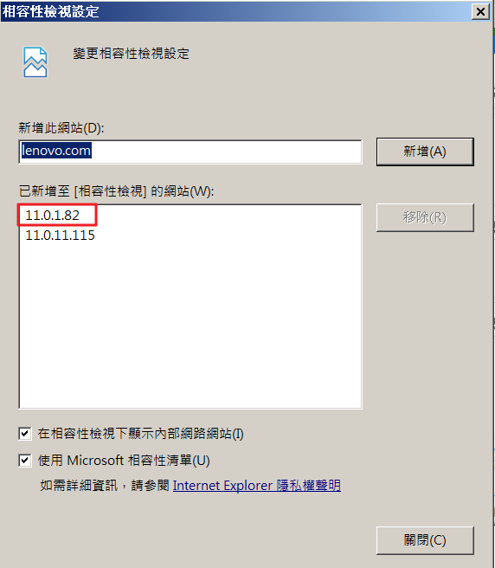

* 1. Date format problem – Go to Control Panel > Region > Set Format to English (United Kingdom)

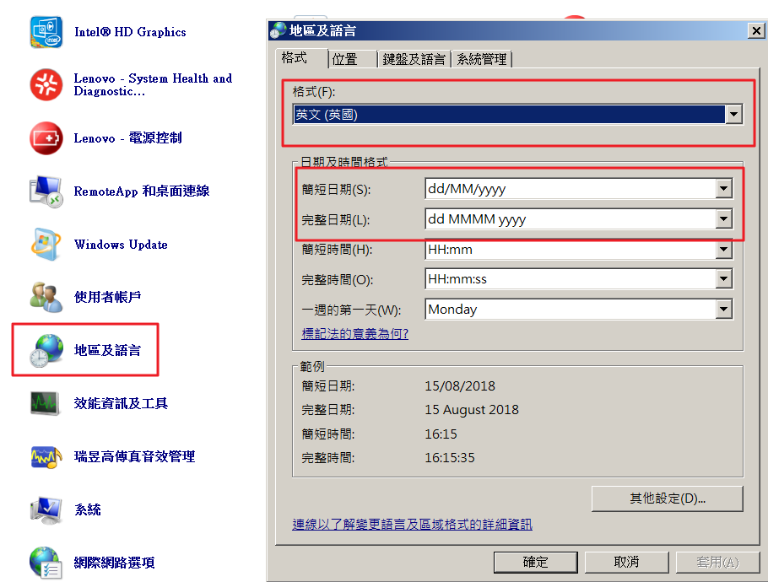

1. PPS Issues (Runs every night)
   1. Check if PPS total amount and Settled amount are balanced next morning
   2. Make sure settled amount are in different Income Cat.

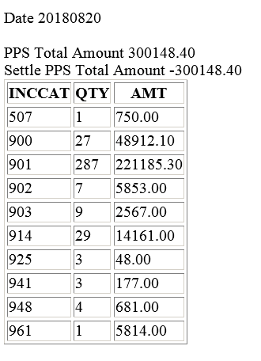

* 1. If PPS job process failed, re-run ‘PPS settlement’ on SRMS

Solution 1

* + 1. ID: i0001 PW: mri
    2. Select ‘HOME’ site
    3. Click on ‘PRINT’ to re-run PPS settlement

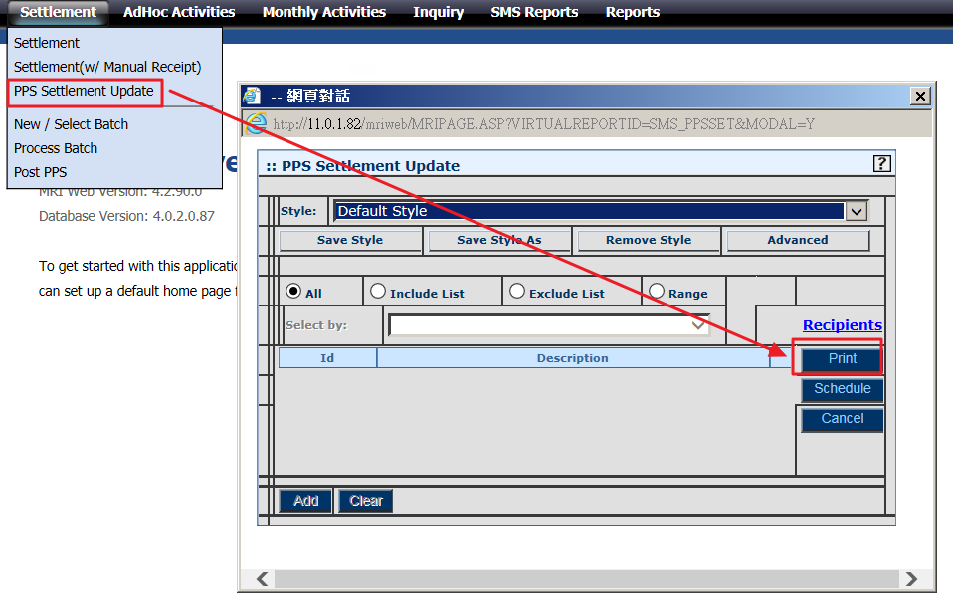

Solution 2

1. If PPS Settlement Update does not work, execute below stored procedure manually

EXEC sp_SMS_PPSSETTLEUPD_SCH_XML

Solution 3

i. If stored procedure does not work, insert event xml manually to scheduler job

INSERT INTO [SCHEDULER_JOBS]

(

[USERID]

,[EVENTXML]

,[SUBMITED_BY]

,[SUBMITED_DATE]

,[STATUS]

)

VALUES

(

'I0001-HOIT',

--'<MRIEVENT><RECURRENCE FREQUENCY="SINGULAR"><DATE>25/3/2011</DATE><TIME>16:12</TIME></RECURRENCE><ACTIONS><ACTION><TYPE>REPORT</TYPE><REPORT>~STYLE=@~SELECTTABLE=CMLEDG~HELPIMG=:: PPS Settlement Update~STYLEDESC=Default Style~REPORTNAME=PPS Settlement Update~SUBJECT=~MESSAGE=~ATTACHFORMAT=~FIXEDSEL=~DISABLESELECTLIST=~DISABLESELECTTABLE=~SELECTTYPE=A~REPORTID=SMS_PPSSET~DESCFIELDCOL=~PROGRAM=MRIRW~</REPORT></ACTION></ACTIONS></MRIEVENT>', --17 Oct updated.

'<MRIEVENT><RECURRENCE FREQUENCY="SINGULAR"><DATE>25/3/2011</DATE><TIME>16:12</TIME></RECURRENCE><ACTIONS><ACTION><TYPE>REPORT</TYPE><REPORT>~STYLE=@~SELECTTABLE=CMLEDG~HELPIMG=:: PPS Settlement Update~STYLEDESC=Default Style~REPORTNAME=PPS Settlement Update~SUBJECT=~MESSAGE=~ATTACHFORMAT=~FIXEDSEL=~DISABLESELECTLIST=~DISABLESELECTTABLE=~SELECTTYPE=A~REPORTID=SMS_PPSSET4~DESCFIELDCOL=~PROGRAM=MRIRW~</REPORT></ACTION></ACTIONS></MRIEVENT>',

'PPS_Settle_Update',

GETDATE(),

'N'

)

1. Autopay Issues (Runs every month on 29th)
   1. Check if all sites have autopay batch and APC files created
   2. If autopay file is missing, manual encrypt process needs to be done
      1. Manual generate APC file on SRMS
      2. Move all APC file to folder (\\11.0.1.80\temp\autopay\[period]\HSBC)
      3. Copy [copy_to_one_file.bat] to 1st folder

Open file with notepad

Edit the combined file name

Copy*.APC autp1808.txt /b /y

Run .bat to combine all autopay charges to one file

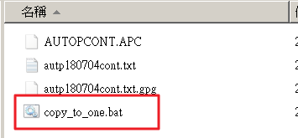

* + 1. GPG encryption process
       1. Remote to 11.0.1.83 (administrator/admin@itd)
       2. Copy the combined file from 11.0.1.80 (MRI DB) to 11.0.1.83 SMRIPPS D:\HSBC\IN
       3. Launch command prompt
       4. Go to D:\MRI\script folder, type ‘encrypt.bat autp[XXXXXX].txt
       5. Copy encrypted file from D:\HSBC\out folder to 11.0.1.80\temp\autopay\yyyymm\hsbc\1st
       6. Send manual generated GPG file to finance for bank submission

1. Autopay Reject Issues (For I.O. Sites)
   1. I.O. sites require password to unzip the reject file and send to site by email
   2. Change bank file from .EX_ to .EXE
   3. Run EXE file and input password to extract file
   4. Remove .DAT extension from extracted file
   5. Copy file to autopay reject folder
   6. Send path to site to process autopay reject

|  |  |  |
| --- | --- | --- |
| **Site Name** | **New Password Eff. (01 June 2018)** | **New Password Eff. (01 Dec 2018)** |
| Arden Court/Hacienda/Wo Ming Court | HSBC-Synergis#421 | HSBC-Synergis#815  HSBC-Synergis#221  HSBC-Synergis#028 |
| Hatton House | HSBC-Synergis#241 | HSBC-Synergis#805  HSBC-Synergis#141  HSBC-Synergis#051 |
| Linden Height | HSBC-Lindenh#137 | HSBC-Lindenh#043  HSBC-Lindenh#210  HSBC-Lindenh#700 |

AutoPay HSBC Reject Email密码tinglwei4858291

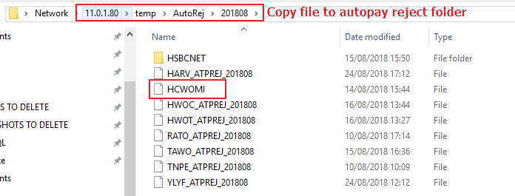

1. Ad-hoc Charges
   1. Create new batch in SRMS
   2. Create new table in temp [11.0.11.014][DAVID_UPLOAD]
   3. Copy batch ID to table along with ad-hoc charges
   4. Run below script and copy column 1 to execute stored procedure (change the highlighted field with new table name)

select '--exec sp_SMS_CreateAdhocCharge ''' + CMBATCHID + ''', ' + '''' + BLDGID + ''', ' + '''' + LEASID + ''', ' + '''' + CONVERT(VARCHAR, INCCAT) + ''', ' + 'N''' + DESCRPTN + ''', ' + '''' + CONVERT(VARCHAR, TRANAMT) + ''', ' + 'N''' + ADDLDESC + '''' ,*

from [11.0.11.104].[david_upload].[dbo].[**70128_956_201808**]

Temp Table Example

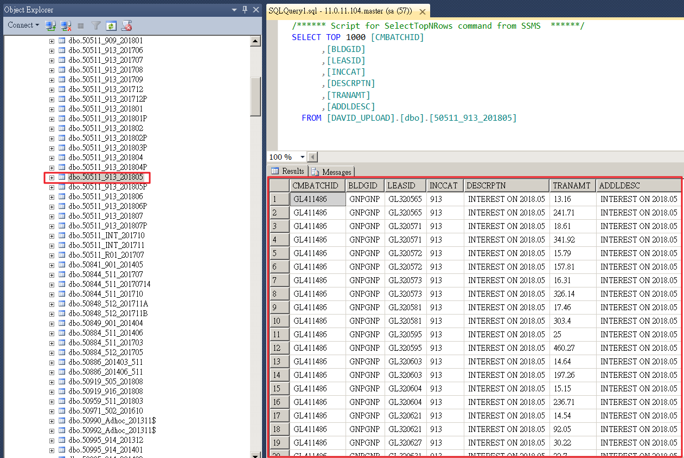

1. New Site Intake
   1. Finance in charge of creating BU/Building ID/Unit ID/Occupant ID/Recurring Charges
   2. IT in charge of creating monthly event for Recurring Charge/Demand Note
2. PROJ_MISC table
   1. Setup autopay details in PROJ_MISC table

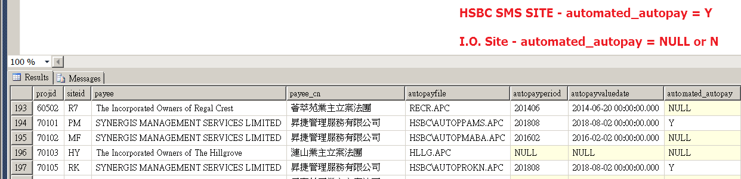

1. Generate Recurring Charge (First time setup)

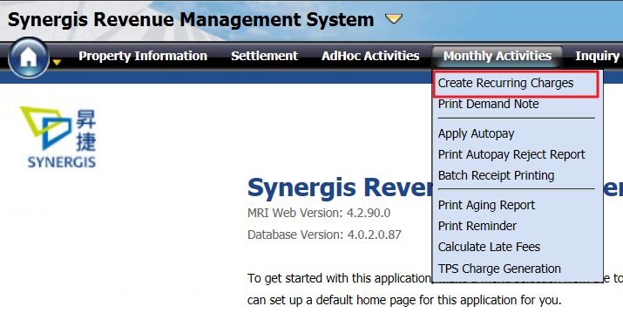

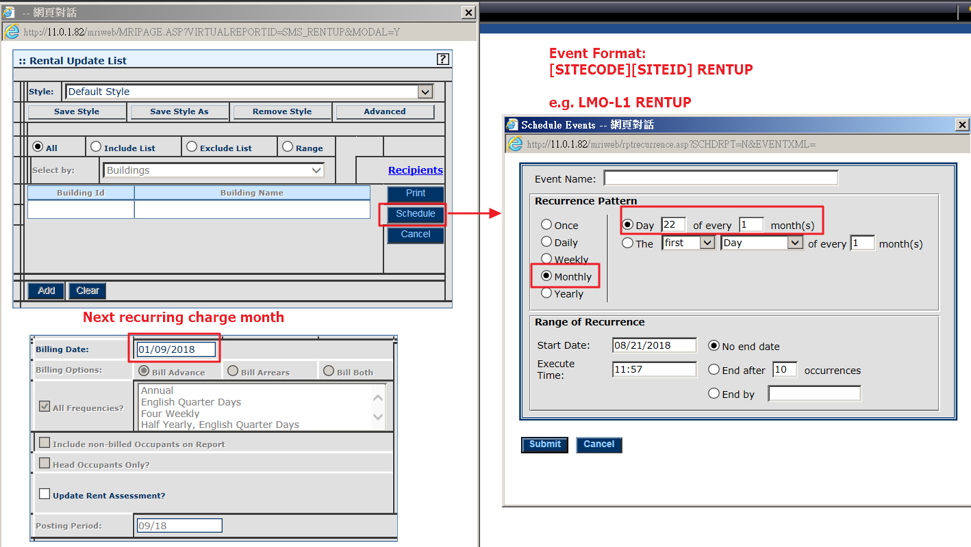



1. Generate Statement of Account (First time setup)

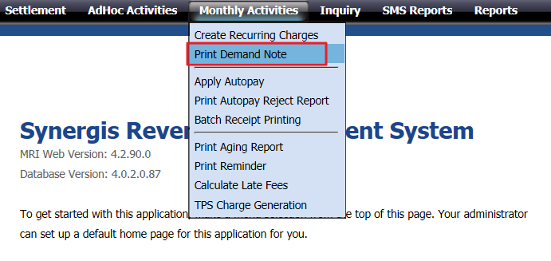

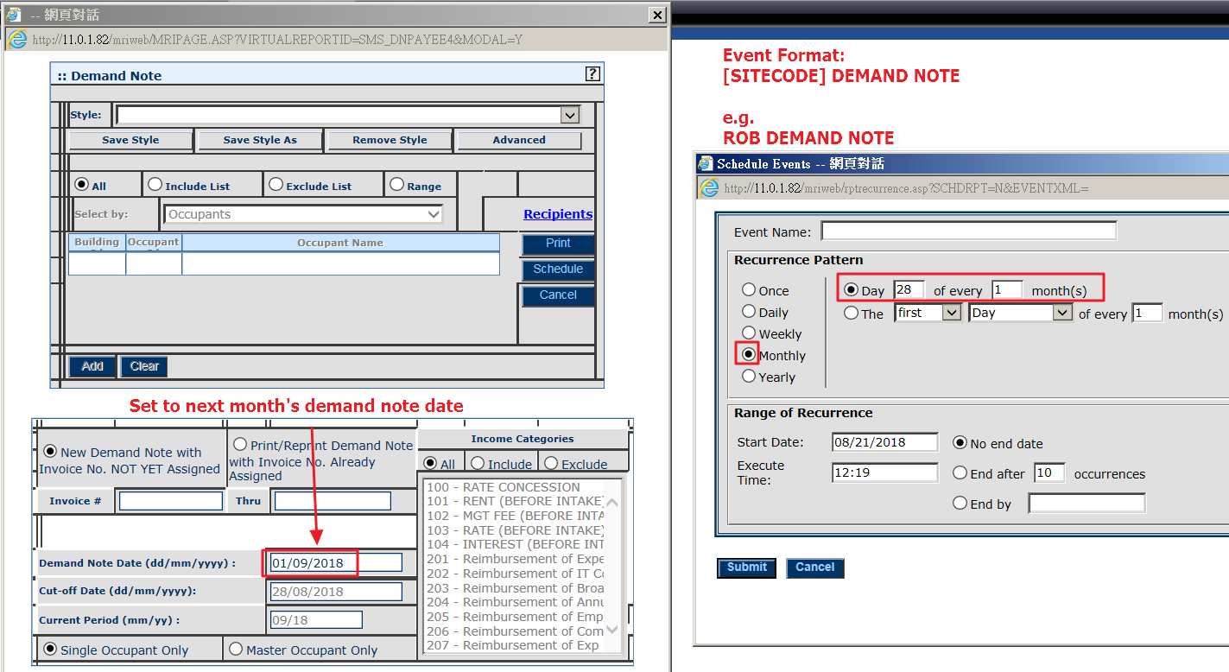

Re-print demand note

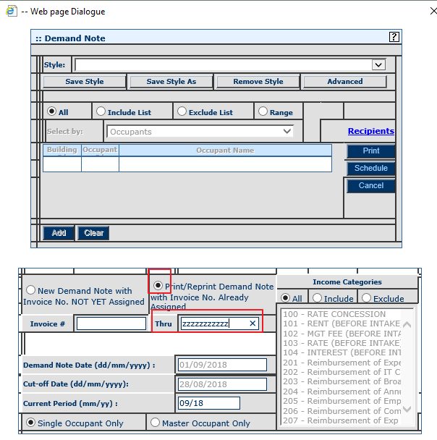

1. Apply Prepayment Process
   1. Occurs every month on 2nd day

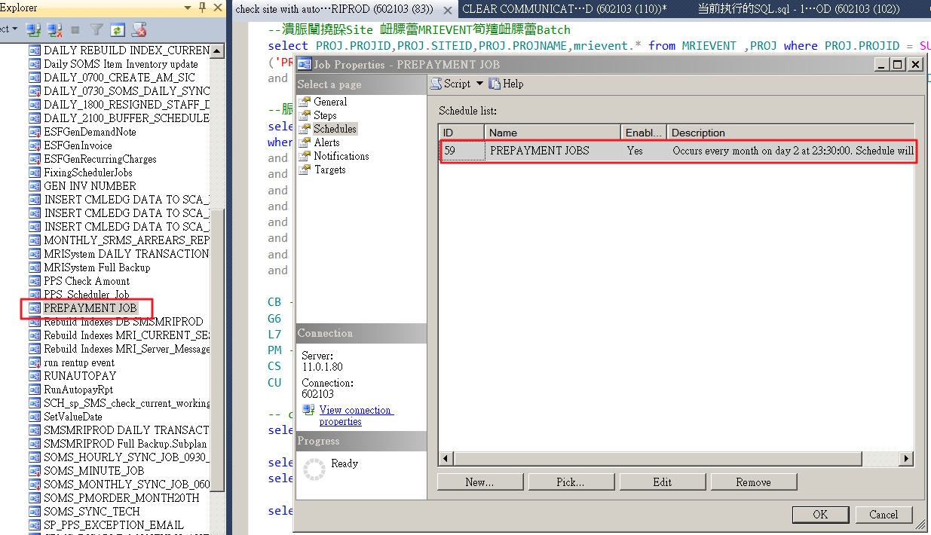

* 1. Apply Prepayment reminder (automatically sent from SIMIS) for sites to post all batch with (900) advance payment transactions

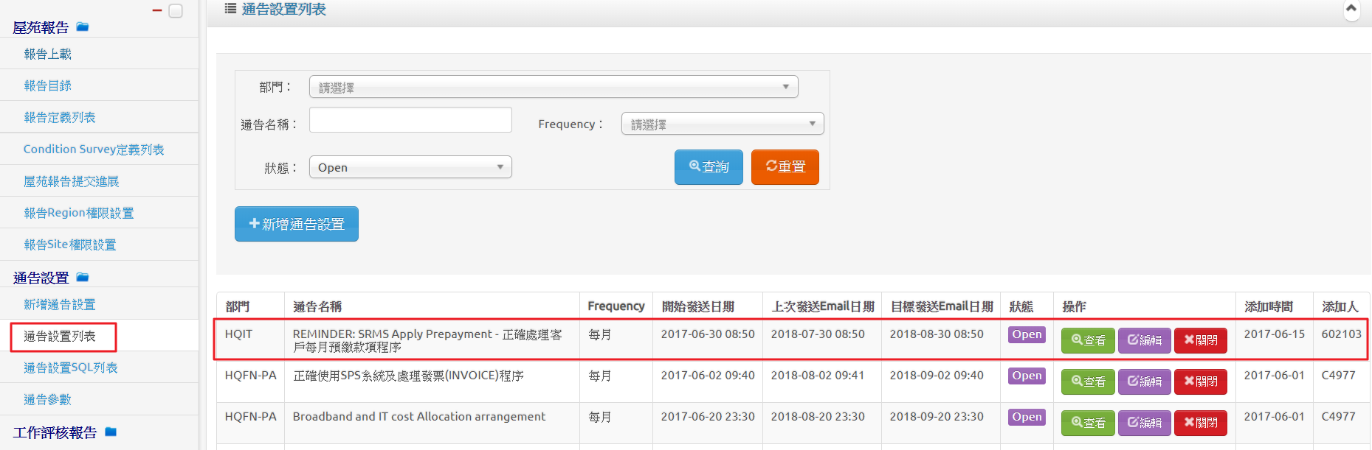

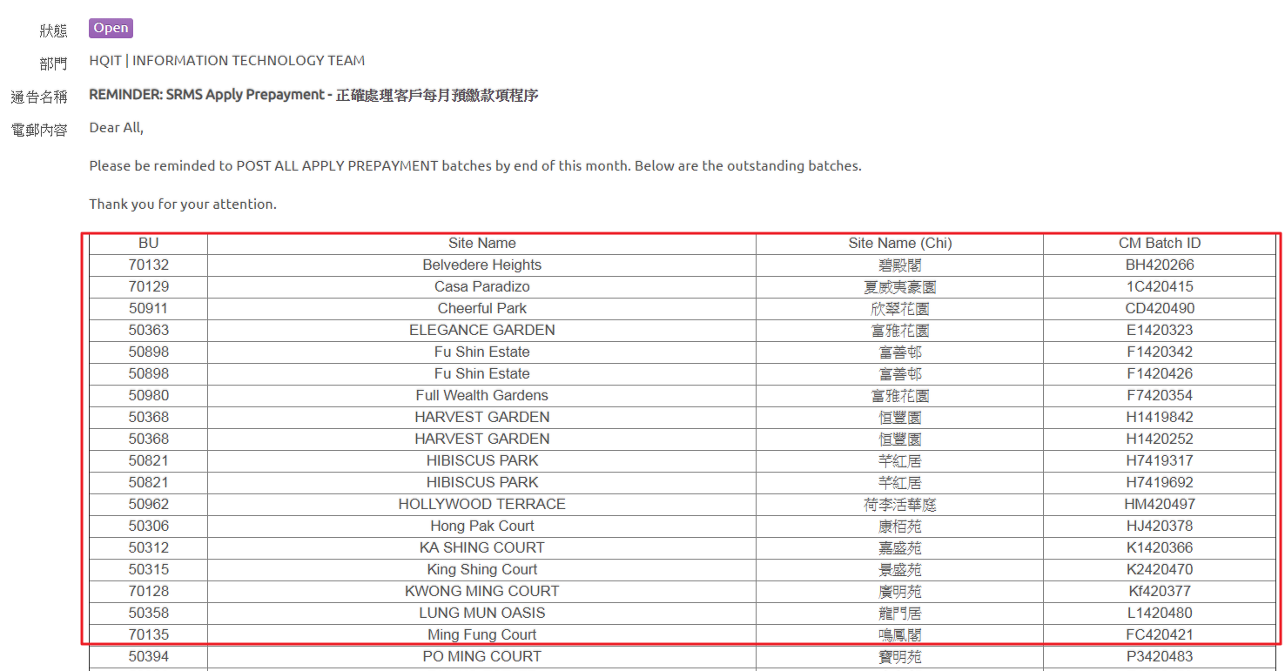

1. Create CM Journal Entries (Change Journal Date/Period)
   1. Change the highlighted fields and run SQL

update mrievent set eventxml = '<MRIEVENT><RECURRENCE FREQUENCY="RECUR"><SPAN SPANNAME="WEEKLY"><FREQ>1</FREQ><WEEKDAY>~sunday~monday~wednesday~friday</WEEKDAY><EFFECTIVE>10/01/2011</EFFECTIVE><EXECTIME>23:59</EXECTIME></SPAN></RECURRENCE> <ACTIONS><ACTION><TYPE>REPORT</TYPE><REPORT>~UPDATE=Y~PROCDATE=28/02/2018~SELECTTABLE=PROJ~HELPIMG=:: Create CM Journal Entries~REPORTNAME=Create CM Journal Entries~REPORTID=MRI_CMCREAJE~MESSAGE=~ATTACHFORMAT=~SUBJECT=~SELECTTYPE=E~SELECTLIST=PROJ|50501|RS217|50220|50223|51816|FF212|RA101|RA102|RA103|RS741|RS244|RS842|RS920|RS246|RS701|SMS-I|SMS-S|SPM-I|SFM-I|50910|50945|50948|~SELECTLISTDATA=PROJ|50501|HSIN CHONG CENTER|RS217|AAT|50220|SYNERGIS|50223|Laundrimate Service Limited|51816|Marina Cove|FF212|MEI FOO PLAZA|RA101|- Name -|RA102|- Name -|RA103|- Name -|RS741|Stanley Plaza|RS244|ESF|RS842|HKUSPACE-Island East Campus|RS920|Hong Kong Academy of Medicine|RS246|HKUSPACE - Kowloon East Campus|RS701|Tak Tin Shopping Centre|SMS-I|SYNERGIS|SMS-S|SMS billing - Site invoice|SPM-I|Synergis Property Mgt Ltd.|SFM-I|Synergis Facility Mgt Ltd.|50910|URA-Shun Sing Mansion|50945|URA-HK H18|50948|33 Argyle Street|~DESCFIELDCOL=2~PROGRAM=MRICMCreajeWeb.CMCreaje~PERIOD=201802~</REPORT></ACTION></ACTIONS></MRIEVENT>' where eventid = '000000000001380'

1. Log on Full Issue
   1. Error message when log on SRMS

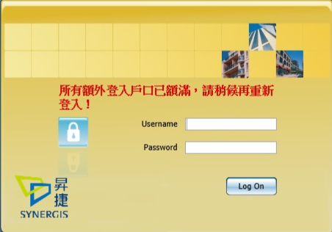

* 1. Force all users to log out from specific site (highlighted value as site ID)

update mrisystem.dbo.MRI_Current_Sessions set logout_time = getdate()

where userid like '%-TJ%' and logout_time is null --Force all user logout at the checking site

15. Check Scheduler Job Table for stuck jobs

select * from dbo.SCHEDULER_JOBS

a. To stop stuck scheduler jobs, update job status to E

UPDATE dbo.SCHEDULER_JOBS SET status = 'E' where ID = '171640'

SRMS Training



1. Copy and paste the below script or open the SQL script from above
2. Edit the Date Join value and run script
3. Copy result to excel sheet and send to L&D department

/*

|----------------------------

| S R M S

|----------------------------

*/

select

a.staffno, a.surname, a.othrname, a.chinname, a.titlename, a.titleChName, a.pldeptname, a.pldeptchname, a.datejoin

, b.business_unit, b.sitename, b.agmregion

, c.telno, c.siteid

, (select count(*) from sms_user where sms_userid collate Chinese_Taiwan_Stroke_CI_AS= a.staffno) as MRI_account

from

scdsvs01.msddb.dbo.staff a

left join scdsvs01.siteprofile.dbo.siteprofile b on replace(b.sitename,' ', '') like '%' +replace(rtrim( a.pldeptname),' ','') +'%' and b.status=3 and b.sitename not like '%Car Park%'

left join proj c on c.projid collate Chinese_Taiwan_Stroke_CI_AS= rtrim(b.business_unit)

where

a.staffno not in ('T2619','T4105','T0057','M3769','T2680','Z5034','T0324','T4069','R1396','R3695')

--and a.staffno not in ('M3844','M9822','T0221','T2380','T4044') --16-Jul-2012 to 16-Jul-2012

and a.DateJoin>='20160301' --##

--and a.TitleName in ('ASSISTANT ESTATE OFFICER','ASSISTANT PROPERTY MANAGER','ESTATE OFFICER','PROPERTY MANAGER','SENIOR ESTATE OFFICER','CLERK')

and b.agmregion in ('KTTW','HKELT','PMNTE','PMNTW','FM1','KLNTK','HK','KLN','NTE','NTW')

and (select count(*) from sms_user where sms_userid collate Chinese_Taiwan_Stroke_CI_AS= a.staffno) > 0

order by

a.staffno

--a.datejoin

SOMS Training

1. Copy and paste the below script
2. Edit the Date Join value and run script
3. Copy result to excel sheet and send to L&D department

/*

|----------------------------

| S O M S

|----------------------------

*/

select

a.DATERESGN,

a.staffno, a.surname, a.othrname, a.chinname, a.titlename, a.titleChName, a.pldeptname, a.pldeptchname, a.datejoin

, b.business_unit, b.sitename, b.agmregion

, c.telno, c.siteid

, (select count(*) from sms_user where sms_userid collate Chinese_Taiwan_Stroke_CI_AS= a.staffno) as MRI_account

from

scdsvs01.msddb.dbo.staff a

left join scdsvs01.siteprofile.dbo.siteprofile b on replace(b.sitename,' ', '') like '%' +replace(rtrim( a.pldeptname),' ','') +'%' and b.status=3 and b.sitename not like '%Car Park%'

left join proj c on c.projid collate Chinese_Taiwan_Stroke_CI_AS= rtrim(b.business_unit)

where

a.staffno not in ('T2619','T4105','T0057','M3769','T2680','Z5034','T0324','T4069','R1396','R3695')

and a.DateJoin>='20160301' --##

AND a.DATERESGN = '20991231'

AND business_unit IS NOT NULL

and (select count(*) from sms_user where sms_userid collate Chinese_Taiwan_Stroke_CI_AS= a.staffno) > 0

and a.TitleName in (

'ADMINISTRATIVE ASSISTANT'

,'ADMINISTRATIVE OFFICER'

,'ASSISTANT ADMINISTRATIVE OFFICER'

,'ASSISTANT ESTATE OFFICER'

,'ASSISTANT FACILITY OFFICER'

,'ASSISTANT PROPERTY OFFICER'

,'ASSISTANT TECHNICAL OFFICER'

,'ASSISTANT PROPERTY MANAGER'

,'CLERK'

,'CUSTOMER SERVICE ASSISTANT'

,'CUSTOMER SERVICE ASSISTANT'

,'CUSTOMER SERVICE ASSISTANT - HCCT'

,'ESTATE ASSISTANT'

,'ESTATE OFFICER'

,'FACILITY ASSISTANT'

,'FACILITY MANAGER'

,'FACILITY OFFICER'

,'MAINTENANCE MANAGER'

,'OPERATION OFFICER'

,'PROPERTY OFFICER'

,'SENIOR ADMINISTRATIVE ASSISTANT'

,'SENIOR ESTATE ASSISTANT'

,'SENIOR ESTATE OFFICER'

,'SENIOR FACILITY ASSISTANT'

,'SENIOR FACILITY OFFICER'

,'SENIOR OPERATION ASSISTANT'

,'SENIOR OPERATION OFFICER'

,'SENIOR PROPERTY ASSISTANT'

,'SENIOR PROPERTY OFFICER'

,'SENIOR TECHNICAL OFFICER'

,'SENIOR PROPERTY MANAGER'

,'TECHNICAL OFFICER')

order by

a.staffno

--a.datejoin

SOMS Issue

1. SOMS – Add technician
   1. Use the below SQL to check if technician exists in database

SELECT * from [SMSMRIPROD].[dbo].[TB_MM_TECH] where technicianid = 'MZ00025'

* 1. Use the below SQL to add new technician to database

[STAFF ID][STAFF NAME][FIRST NAME][LAST NAME]

Insert into [SMSMRIPROD].[dbo].[TB_MM_TECH](TECHNICIANID,FILEASNAME,FIRSTNAME,LASTNAME)

Values('MZ00025','HO CHI CHUNG','CHI CHUNG','HO');

1. SOMS – New site setup
   1. Send template to site user to complete
   2. Fill in Step 1 to Step 3 (Follow the rules on template)

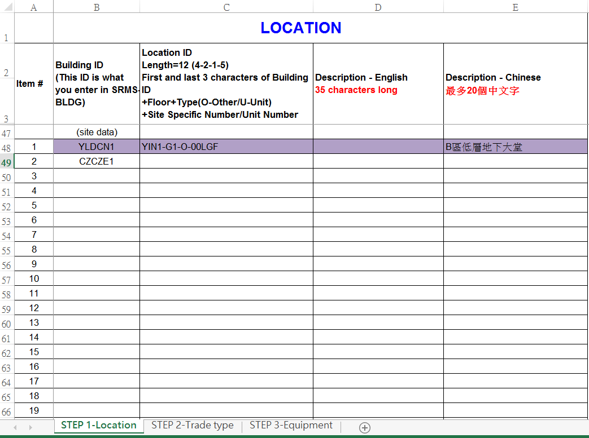

* 1. Upload STEP 1 - location list to [SMSMRIPROD].[dbo].[TB_MM_LOCATION]
  2. Upload STEP 2 – trade type list to [SMSMRIPROD].[dbo].[TB_MM_TRADETYPE]

[SMSMRIPROD].[dbo].[TB_MM_TRADETYPEL2]

[SMSMRIPROD].[dbo].[TB_MM_TRADETYPEL3]

[SMSMRIPROD].[dbo].[TB_MM_TRADETYPEL4]

